Prog assignment 3

Documentation

Added in try catches in assignment 3

Db script for appointment

create table tblAppoinments

(

PatientName varchar (255) not null,

PatientSurname varchar (255) not null,

contactNumber varchar (10) not null,

AppointmentDateTime VARCHAR (255) not null primary key

)

and login

use [progAssigment2]

create table tblLogin

(

username varchar (255) not null primary key,

userPassword varchar (255) not null

)

I have hosted my db on azure.

Needs internet access of at least 2 mbps to run smotthly

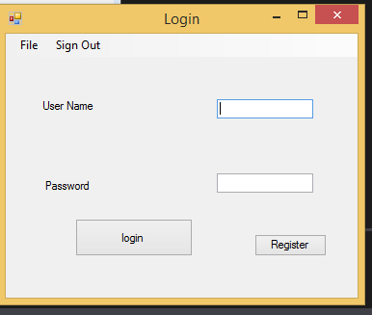

login screen

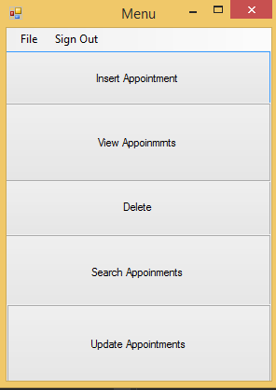

form menu

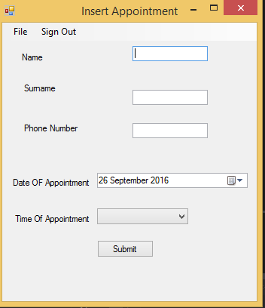

insert appointment

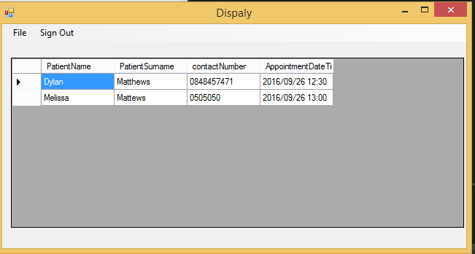

the display in grid box

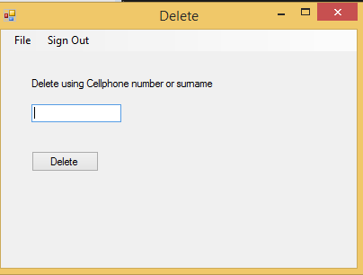

delete form

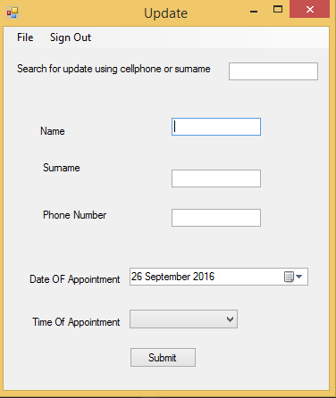

update form